20.37: a) 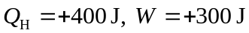
Since it is a Carnot cycle, 